Background Part 1 (IO Devices, CPU and Memory)

Before we begin our programming journey, it's important to understand some basic hardware concepts. This article will help you review the topics covered in the video, including input and output devices, the Central Processing Unit (CPU), different types of memory, and the role of the Operating System (OS).
Input and Output Devices
Input Devices: These are tools we use to send information to the computer. Here are some common input devices:
- Keyboard: Used to type text and commands into the computer.
- Mouse: Allows you to move the cursor and select items on the screen.
- Touchpad: Similar to a mouse, used mainly on laptops to move the cursor.
- Scanner: Converts physical documents into digital files.
- Microphone: Captures audio input for the computer.
Output Devices: These devices display or produce the results from the computer. Common output devices include:
- Display Screen: Shows visuals like text, images, and videos.
- Speakers: Play sound from the computer.
- Earphones: Provide audio output and often include a microphone for input.
- Printer/Scanner Combo: Can print documents (output) and scan physical documents (input).
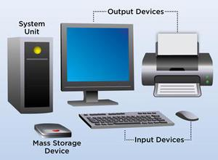Example of various input and output devices connected to a computer.
CPU and Memory
Central Processing Unit (CPU): The CPU is like the brain of the computer. It performs all the calculations and processes the data you work with. Because the CPU does a lot of work, it can get hot, so it is usually kept cool with a fan.
Types of Memory:
- Cache Memory:
  - Located directly on the CPU chip.
  - Provides quick access to frequently used data.
- Main Memory (RAM - Random Access Memory):
  - Temporary storage for programs and data that are currently in use.
  - Data in RAM is lost when the computer is turned off.
  - When you run a program, it is loaded from the hard disk into RAM for faster access by the CPU.
- Secondary Storage (Hard Disk):
  - Permanent storage for data and programs.
  - Data remains stored even when the computer is turned off.
  - Examples include internal and external hard disks, DVDs, CDs, and USB drives.
Role of the Operating System
Operating System (OS): The OS is essential software that manages all the hardware and other software on your computer. It controls how the CPU, memory, and input/output devices work together. The OS ensures that each program gets the resources it needs to run smoothly.
Examples of Operating Systems:
- Microsoft Windows (e.g., Windows 10, Windows 7)
- Linux (various distributions like Ubuntu, CentOS)
- Unix
- macOS (used on Apple devices)

Background Part 2 (Computer Organization)

Let us explore how different devices are organized within a computer. We will focus on the Central Processing Unit (CPU), various types of memory, and how they interact with each other. Understanding this organization is essential for knowing how data is managed and accessed in a computer system.
Why We Have Different Types of Memory
Computers use different types of memory to balance three main features:
- Low Access Time: The CPU should quickly access data from memory.
- Low Cost: Memory should be affordable.
- High Capacity: Memory should store large amounts of data.
No single type of memory perfectly balances all these features, which is why multiple memory types are used.
Types of Memory
- Cache Memory:
  - Located within the CPU chip itself.
  - Has very low access time, allowing the CPU to access data quickly.
  - Expensive and has limited capacity.
- Main Memory (Random Access Memory, RAM):
  - Offers a balance between speed, cost, and capacity.
  - Stores data and programs that are currently in use.
- Secondary Storage:
  - Includes devices like hard disks, DVDs, CDs, and USB drives.
  - Provides high-capacity storage at a low cost but has higher access times compared to cache and main memory.
  - Non-volatile, meaning it retains data even when the computer is turned off.
Volatile vs. Non-Volatile Memory
- Volatile Memory: Includes cache memory and main memory (RAM). Data is lost when the computer is turned off.
- Non-Volatile Memory: Includes secondary storage like hard disks. Data is retained even when the computer is turned off.
Shopkeeper's Store Analogy
To better understand memory organization, imagine a shopkeeper organizing their store:
- Front Counter (Cache Memory): The shopkeeper keeps the most frequently sold items at the front counter for quick access, similar to how cache memory holds frequently accessed data for the CPU.
- Shop Area (Main Memory): Items that are used often but not as frequently as those on the front counter are stored here, much like how main memory holds data currently in use.
- Storage Room (Secondary Storage): Rarely needed items are kept in the storage room. If a customer requests an item not on the front counter or in the shop area, the shopkeeper retrieves it from the storage room, just as the operating system fetches data from secondary storage when it's not in cache or main memory.
Memory Hierarchy and Data Access
The CPU always tries to fetch data from the cache first due to its speed. If the required data is not in the cache, the CPU looks in the main memory. If the data is still not found, it is fetched from the secondary storage. This hierarchical approach ensures efficient data access and resource management.
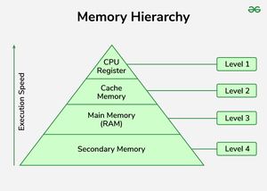Memory Hierarchy
Operating System's Role
The Operating System (OS) manages how data moves between the CPU, cache memory, main memory (RAM), and secondary storage. It ensures that when the CPU needs data, the OS retrieves it from the fastest available memory. If the data isn't in the cache or main memory, the OS fetches it from the secondary storage and moves it into the main memory for quicker access next time.

Why Do We Need Programming Languages

In this article, we will explore the Central Processing Unit (CPU), the role of programming languages, and the tools that help translate human-readable code into machine-understandable instructions. We will also discuss why Python is a preferred language for beginners and experienced programmers alike.
The Role of the Central Processing Unit (CPU)
The CPU is the brain of the computer, designed to perform computations rapidly. For example, generating multiplication tables for the first thousand numbers manually would require significant time and effort. However, the CPU can perform this task quickly by following the right instructions.
Writing Programs for the CPU
The CPU understands instructions in a format called binary, which is a sequence of 0s and 1s. Writing programs directly in binary is very difficult for humans because remembering and writing long sequences of 0s and 1s is impractical. This is where high-level programming languages come into play.
Programming Languages
Programming languages like C, C++, Java, and Python provide a more readable and writable syntax for humans to give instructions to the CPU. These languages have specific rules, known as syntax, that programmers must follow carefully. Unlike everyday languages like English or Hindi, where minor mistakes can still be understood, programming languages require exact syntax to work correctly. A single mistake can lead to errors in the program.
Compilers and Interpreters
To convert the code written in high-level programming languages into binary code that the CPU can understand, we use tools called compilers and interpreters.
- Compiler: A compiler takes the entire code that you've written and converts it into machine language all at once, creating an executable file that the computer can run.
- Interpreter: An interpreter converts and executes the code one line at a time, rather than processing the entire program at once.
Why Python?
Among various programming languages, Python is known for its simplicity and readability. Here are some reasons why Python is often preferred:
- Its syntax is closer to English, making it easier for beginners to learn and understand.
- Python is concise, meaning you can achieve a lot with fewer lines of code.
- This makes Python not only accessible but also powerful, allowing programmers to write efficient code quickly.

Introduction to Python

Python is a widely-used, general-purpose, high-level programming language. It was created by Guido van Rossum in 1991 and has since gained immense popularity for its simplicity and versatility. Its syntax is user-friendly, making it accessible to beginners while remaining powerful for advanced developers.
A Brief History and Popularity
Python was designed with a focus on readability and reducing the complexity of coding. Over the years, it has become one of the most popular programming languages, powering a wide range of applications and systems.
Why Python?
Python's simple and intuitive syntax allows programmers to express concepts clearly and efficiently. It is a general-purpose language, which means it can be used for:
- Console Applications and scripting
- Desktop Applications
- Web Applications
- Game Development
- Advanced Fields like Machine Learning (ML), Deep Learning (DL), Artificial Intelligence (AI), Big Data, Internet of Things (IoT), and more.
Multi-Paradigm Support
Python supports multiple programming paradigms, making it highly flexible:
- Procedural Programming like C
- Object-Oriented Programming (OOP) like Java
- Functional Programming like Lisp
Portability
Python is platform-independent, which means it can run on multiple operating systems like Windows, Linux, and macOS. Python programs are first compiled into an intermediate bytecode, which is then executed by the Python interpreter, ensuring consistency across platforms.
Dynamically Typed
Python is a dynamically typed language, meaning the type of a variable is determined at runtime. While this adds flexibility, it can also make Python slower compared to statically typed languages.
Garbage Collection
Python includes built-in garbage collection, which automatically manages memory by deallocating unused objects. This feature simplifies the programmer's job and helps prevent memory leaks.
Applications Built Using Python
Python's versatility has made it a preferred choice for developing several well-known applications and platforms, such as:
- YouTube
- Dropbox
- Reddit
- Quora
- Instagram
- Mozilla Firefox
- Netflix
- Our platform (shifting from PHP to Python)

Python Standard and Implementations

In this article, we will explore the Python standard and various implementations of the Python programming language. This knowledge is crucial for developers who want to understand how Python works behind the scenes and how different implementations can impact their projects.
The Python Standard
Just like human languages have grammar rules, programming languages have standards that define how they should be written and executed. For Python, these rules are encapsulated in the Python Standard. As of November 2024, the latest stable version is Python 3.13.0.
Key Rules of Python Standard
- Case Sensitivity: Variables and identifiers in Python are case-sensitive. For example, Variable and variable would be considered different.
- Operators: Python uses specific operators for different operations. For instance, the * operator is used for multiplication.
- Indentation: Python uses indentation to define blocks of code, unlike many other languages that use braces {}.
The Python documentation, found at docs.python.org, provides comprehensive details about these rules and more.
Python Implementations
Python can be implemented in various ways, each designed to optimize different aspects of the language.
CPython
- Description: The default and most widely used implementation of Python, written in C.
- Usage: Found in most tutorials and widely used in the industry.
- Advantages: It is highly compatible with C extensions, making it versatile and robust for various applications.
Jython
- Description: An implementation of Python written in Java.
- Usage: Enables seamless integration with Java libraries.
- Advantages: Allows Python to run on any platform with a Java Virtual Machine (JVM), making it ideal for Java developers.
IronPython
- Description: An implementation designed for the .NET framework, written in C#.
- Usage: Used for integrating Python with .NET applications.
- Advantages: Provides compatibility with .NET libraries and tools, beneficial for developers working within the Microsoft ecosystem.
PyPy
- Description: A Python implementation known for its speed, using just-in-time (JIT) compilation.
- Usage: Often used in performance-critical applications.
- Advantages: Significantly faster execution compared to CPython due to its JIT compiler, which translates Python code into machine code at runtime.
Why Different Implementations?
Different implementations of Python exist to optimize for various environments and requirements. CPython remains the most popular due to its broad compatibility and extensive use in the industry. However, other implementations like PyPy offer significant performance improvements, and Jython or IronPython provide better integration with Java and .NET ecosystems, respectively.

How Python Programs Are Executed

Python is a popular programming language known for its simplicity and flexibility. Understanding the process of Python program execution can help developers write efficient and platform-independent code. This article breaks down the steps involved in executing Python programs, highlighting the compilation, interpretation process, and portability.
Writing Python Programs
When you write a Python program, you create a file with a .py extension. This file contains the source code of your program and can be created using any text editor, such as Notepad or VI Editor. Alternatively, you can use Integrated Development Environments (IDEs) like PyCharm, which offer additional tools to simplify coding.
Execution Process in Python
Python uses a two-step process to execute programs, involving both compilation and interpretation:
1. Compilation to Bytecode:
- The .py file (your source code) is first compiled into an intermediate format called bytecode.
- The resulting bytecode files have a .pyc extension.
- This step is performed by the Python compiler.
2. Interpretation of Bytecode:
- The bytecode is executed line by line by the interpreter.
- The interpreter translates the bytecode into machine-specific instructions, enabling execution on your computer.
Why Both Compilation and Interpretation?
Languages like C and C++ typically use only a compilation step, directly converting source code into machine-specific binary code. However, Python employs a two-step process to enhance portability.
Portability in Python
Portability means that a Python program can run on various platforms (a combination of operating system and architecture) without modification. For example, Python programs can run on Windows, Linux, or macOS.
1. Platform-Independent Bytecode:
- Python first compiles the source code into platform-independent bytecode.
- This bytecode can be distributed and executed on any machine with a Python Virtual Machine (PVM) installed.
2. Python Virtual Machine (PVM):
- The PVM interprets and executes the bytecode on the specific platform.
- Each platform (e.g., Windows, Linux) has its version of the PVM to ensure compatibility.
Example Execution Process
Here’s a step-by-step example of how a Python program is executed:
1. Writing the Program:
- Write your Python code and save it as example.py.
2. Running the Program:
- Run the program from the command line using: python example.py.
- The Python interpreter compiles example.py into bytecode, producing example.pyc.
- The interpreter then executes the bytecode line by line.
Command Line and IDE Execution
1. Command Line:
- Use the terminal or command prompt to execute Python programs.
- Run your program with a command like python example.py.
2. Integrated Development Environments (IDEs):
- IDEs like PyCharm offer features such as built-in terminals and shortcuts to simplify running Python programs.
Verifying Compilation
If you want to see the compilation step in action, you can use a specific command to compile your Python program without executing it:
python -m py_compile example.py
This command generates a .pyc file containing the bytecode, which you can inspect.

Python Programming Terminology

Understanding the basic terminology in Python programming is essential for anyone looking to become proficient in this versatile language. Here are some key terms and concepts you'll encounter frequently:
Keywords
Keywords are reserved words in Python used for specific purposes. They form the syntax of the language and cannot be used as identifiers (names for variables, functions, etc.). Examples of keywords include:
- for and while for loops
- True and False for boolean values
Variables
Variables are names that reference a memory location where data is stored. They are user-defined and cannot be named using keywords. For example:
x = 5
Here, 5 is stored at some memory location, and x is a variable referencing that location.
Functions
Functions are sequences of instructions that perform a specific task. They can take inputs, process them, and return outputs. For instance:
- The print function displays output on the screen:
print("Hello, World!")
- The input function takes user input:
x = input("Enter your name: ")
Classes and Objects
Classes are blueprints for creating objects. They encapsulate data for the object and methods to manipulate that data. For example, in a college management software:
- A Student class might have attributes like name and rollNumber, and methods like getMarks.
- A Teacher class might have attributes like name and subject, and methods like assignGrade.
Objects are instances of classes.
In Python, everything is an object, including primitive data types like integers and strings.
Modules and Packages
Modules are Python files that contain related code, such as functions and classes. They help in organizing and reusing code. For example:
import math
print(math.factorial(5))
Packages are collections of modules organized in directories. They help manage large codebases by grouping related modules. A package may contain sub-packages and modules:
college/
__init__.py
student.py
teacher.py
courses/
__init__.py
cs_course.py
ec_course.py
Importing Modules
To use a module in another module, you use the import statement. For example:
import math
print(math.sqrt(16))
If a module is part of a package, you use dotted notation:
from college.student import Student
Python Path
The Python Path is an environment variable that specifies the directories where Python looks for modules. When you import a module, Python searches for it in the following order:
1. The current directory
2. Directories listed in the PYTHONPATH environment variable
3. Standard library directories

Python Installation and First Program

Python is a popular programming language known for its simplicity and readability. This guide will walk you through the process of installing Python and running your first program.
Step 1: Install Python
To get started with Python, you need to install the Python interpreter, which you can download from the official Python website.
1. Download Python:
- Open your web browser and go to https://www.python.org/downloads/.
- Click on the "Download" button to download the latest version of Python.
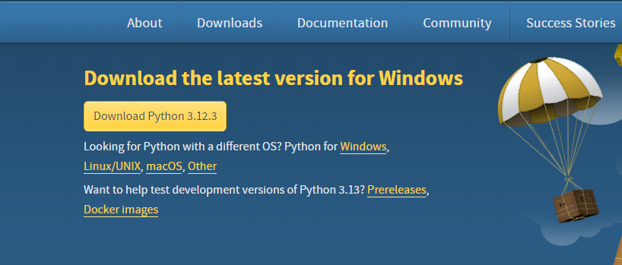
2. Install Python:
Once the download is complete, run the installer program. On Windows , it will typically be a .exe file , on macOS , it will be a .pkg file , and on Linux , it will be a .tar.gz file .
- Once the download is complete, open the installer by double-clicking the downloaded file.
- Click "Install Now" to start the installation process.
- After the installation is complete, Python will be ready to use.
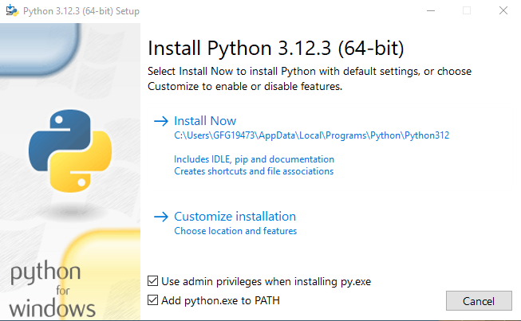

Step 2: Set Up an Integrated Development Environment (IDE)
An Integrated Development Environment (IDE) makes it easier to write and run your Python code. There are several options available:
1. IDLE:
- IDLE is bundled with the Python installation. You can use it to write and execute Python code.
- To open IDLE, go to your system's menu, find Python, and select IDLE..
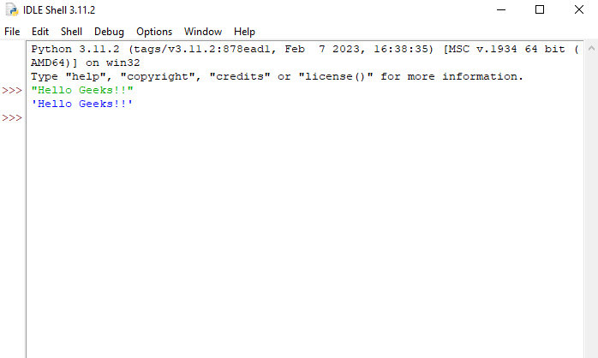
2. PyCharm:
- PyCharm is a popular IDE for Python with many features to enhance your coding experience.
- To download PyCharm, go to jetbrains.com.
- Click on the "Download" button and choose the Community edition (which is free).
- Install PyCharm by following the prompts.
3. Visual Studio Code (VS Code):
- VS Code is another popular IDE that supports Python.
- Download it from https://code.visualstudio.com/.
- Install the Python extension for VS Code to enable Python support.
Step 3: Write and Run Your First Python Program
Once you have Python installed and an IDE set up, you can write and run your first Python program. Here's how you can do it using IDLE and PyCharm.
Using IDLE:
1. Open IDLE:
- Open IDLE from your system's menu.
2. Write Your Program:
- In the IDLE shell, type the following code:
print("Hello, World!")
- Press Enter to run the code.
3. Output:
- You should see Hello,World! printed on the screen.
Using PyCharm:
1. Open PyCharm:
- Launch PyCharm from your system's menu.
2. Create a New Project:
- Click on "New Project".
- Name your project (e.g., "First Project") and click "Create".
3. Create a New Python File:
- Right-click on the project name in the left panel.
- Select "New" -> "Python File".
- Name the file (e.g., hello.py).
4. Write Your Program:
- In the new file, type the following code:
print("Hello, World!")
5. Run Your Program:
- Right-click on the file and select "Run 'hello'".
- You should see Hello,World! printed in the output window.
Step 4: Using the Command Line
If you prefer not to use an IDE, you can write your Python code in a simple text editor and run it from the command line.
1. Write Your Program:
- Open a text editor (e.g., Notepad) and type the following code:
print("Hello, World!")
- Save the file with a .py extension (e.g., hello.py).
2. Run Your Program:
- Open a command prompt or terminal.
- Navigate to the directory where you saved your Python file.
- Type the following command and press Enter:
python hello.py
- You should see Hello,World! printed on the screen.

n, class, or module.
Example of a Docstring
def add(a, b):
"""
This function adds two numbers.

Parameters:
a (int): The first number.
b (int): The second number.

Returns:
int: The sum of the two numbers.
"""
return a + b
The docstring explains what the function add does, its parameters, and what it returns.
Difference Between Comments and Docstrings
- Comments:
  - Explain how the code works.
  - Ignored by the interpreter.
  - Used for internal logic explanations.
- Docstrings:
  - Document what the code does.
  - Processed and accessible through the interpreter.
  - Used to describe the interface and usage of functions, classes, or modules.

